PDA Project Unit

Simon Atkins

Cohort e20

## P.1 Github Contributors Page

## P.2 Project Brief

## P.3 Use of Trello

## P.4 Acceptance Criteria

## P.5 User Sitemap

User sitemap for Troll Shelter project

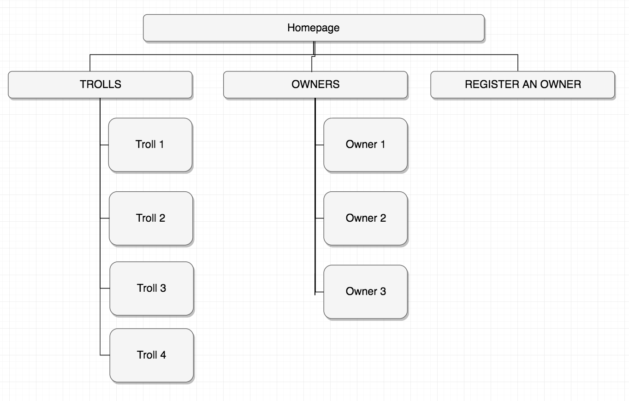

## P.6 Wireframe Designs

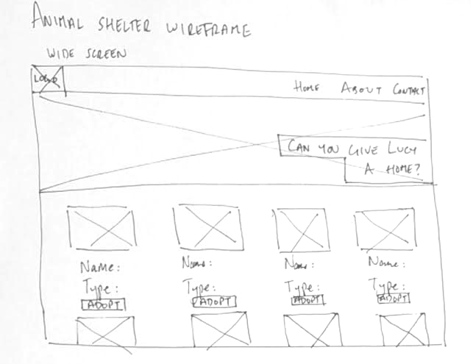

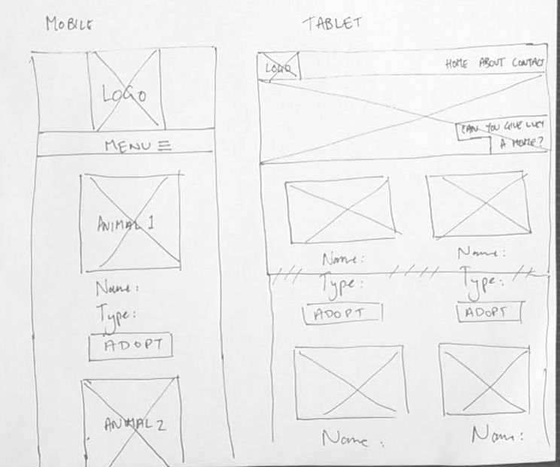

## P.7 System Interactions Diagrams

## P.8 Two Object Diagrams

## P.9 Two Algorithms

On this example please take a screenshot and write what it is doing and why you have decided to use it

## P.10 Example of Pseudocode

Pseudocode instructions for Ruby function to select data from SQL database

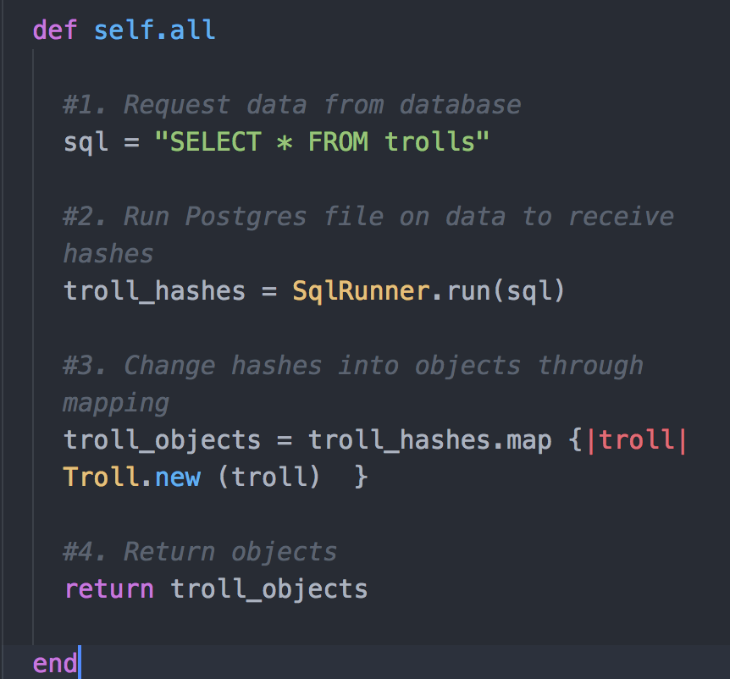

## P.11 Github link to one of your projects

<https://github.com/this-is-simon/cc_w8d3_android_TopGuitars>

In this project I worked alone on an Android app to display Iconic Guitars.

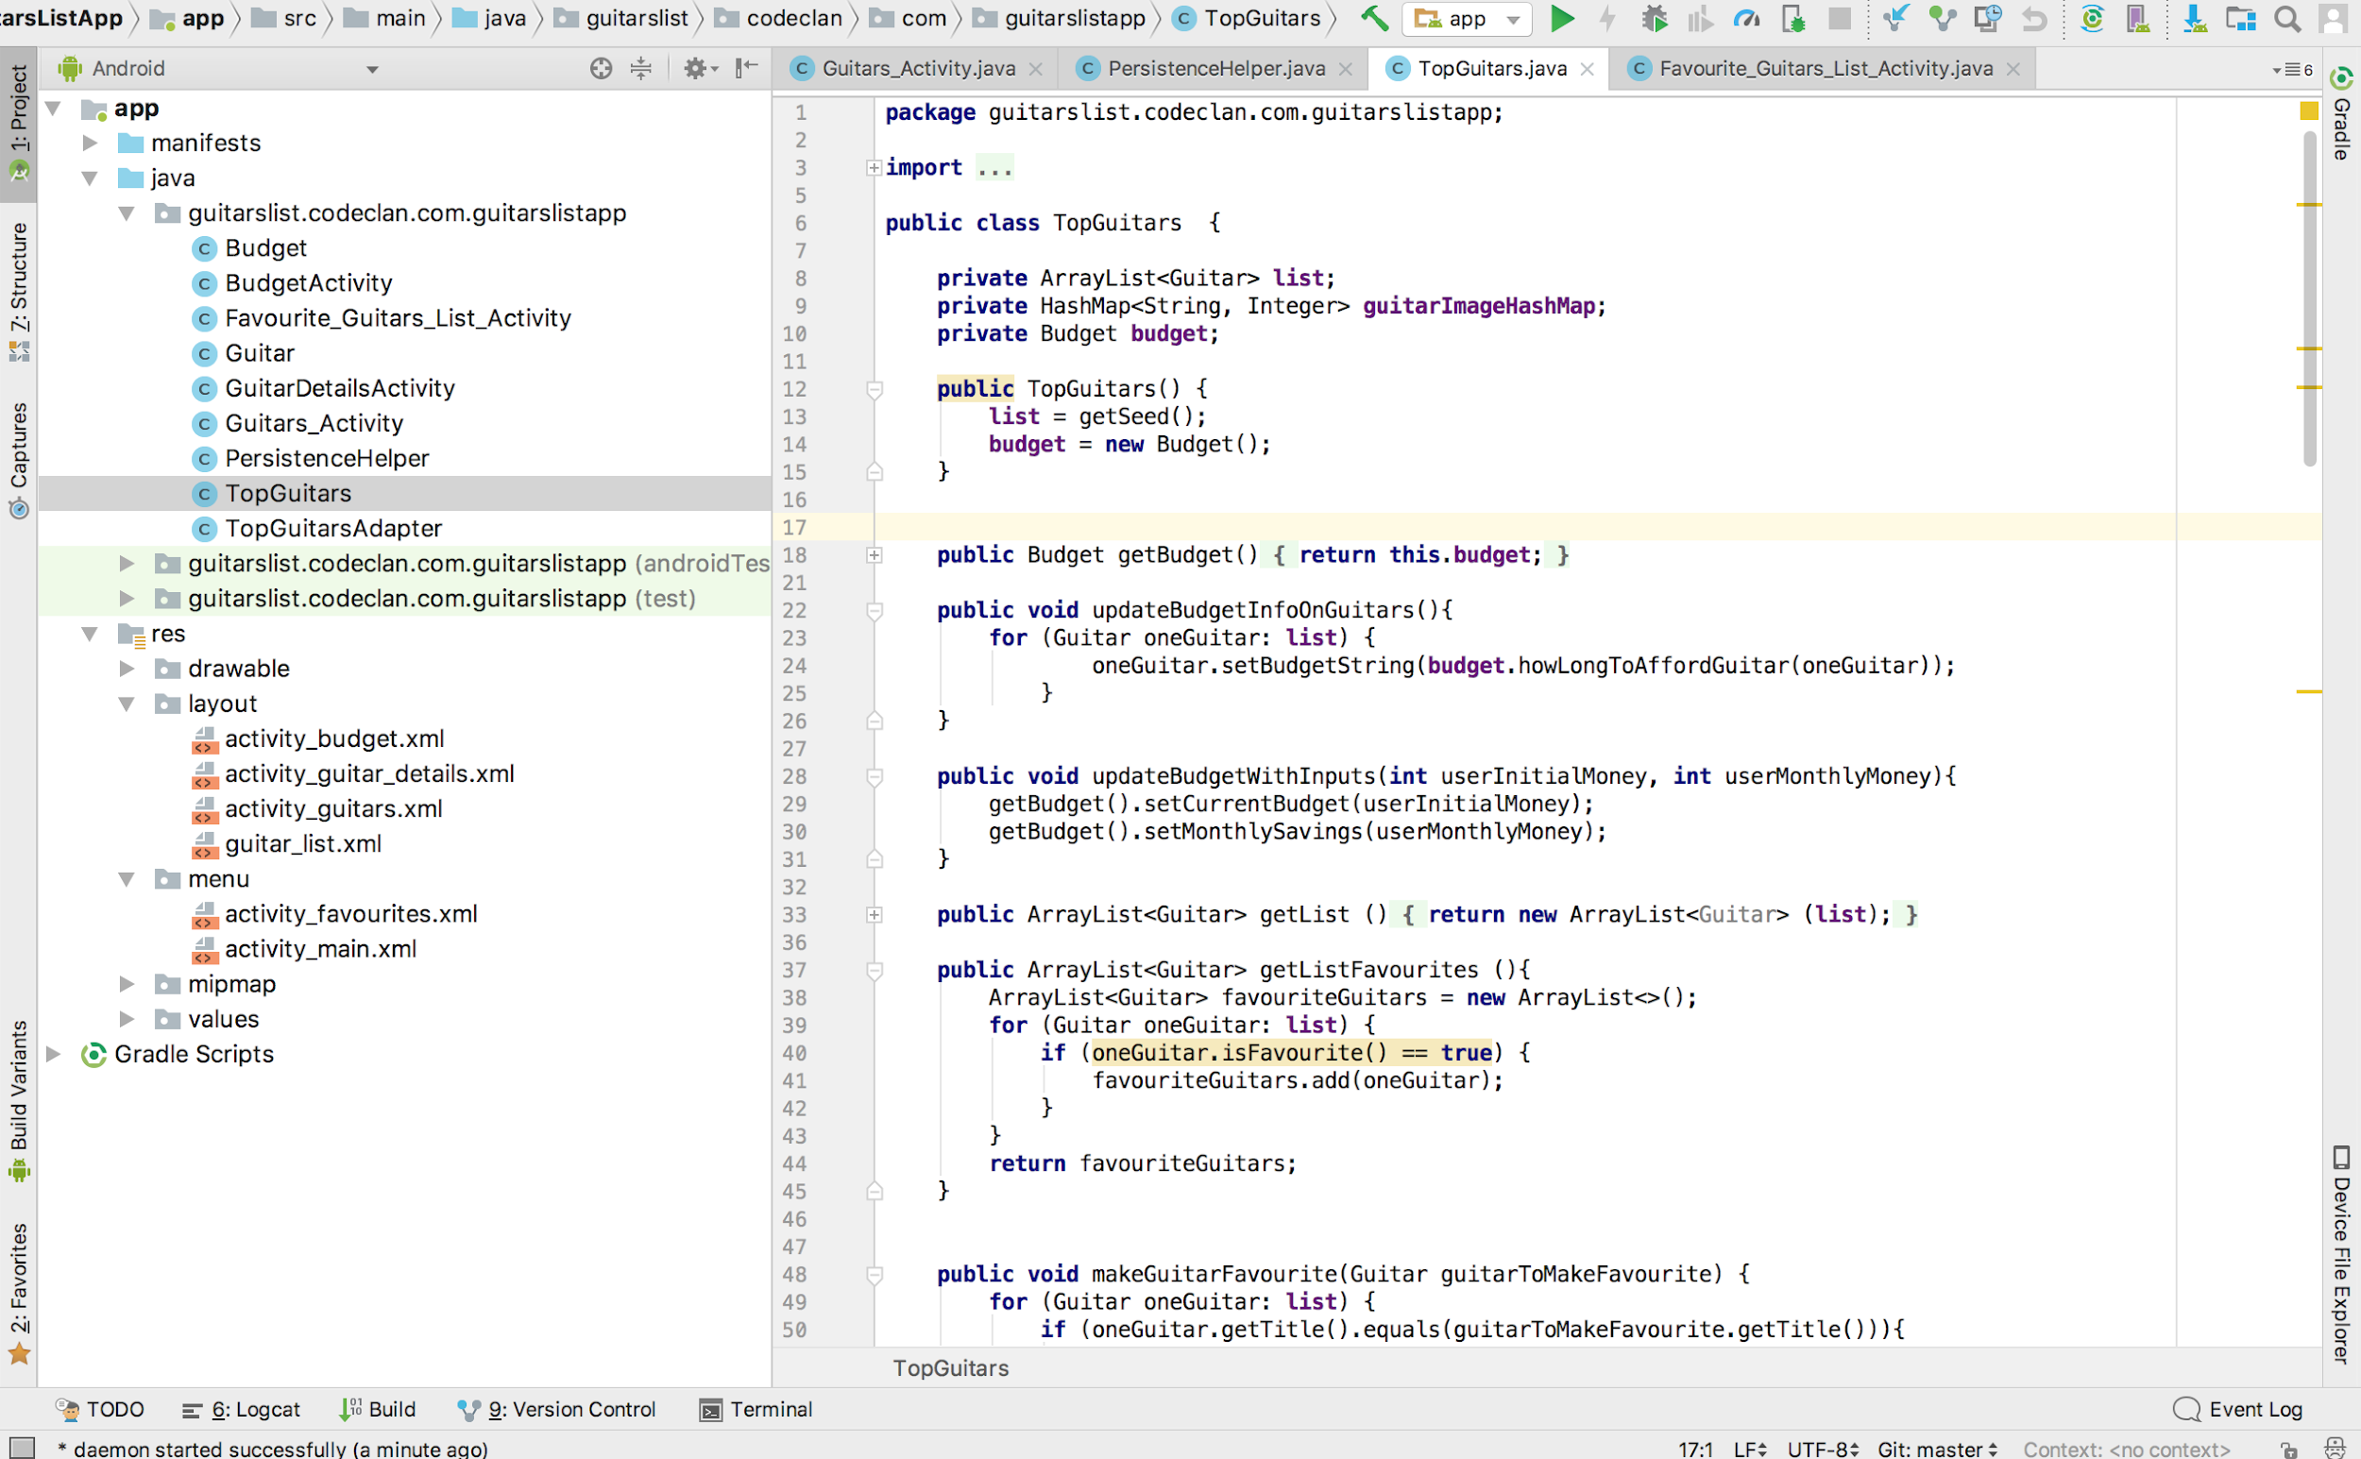

## P.12 Screenshot of your planning and different stages of development to show changes

1. Planning project using Trello:

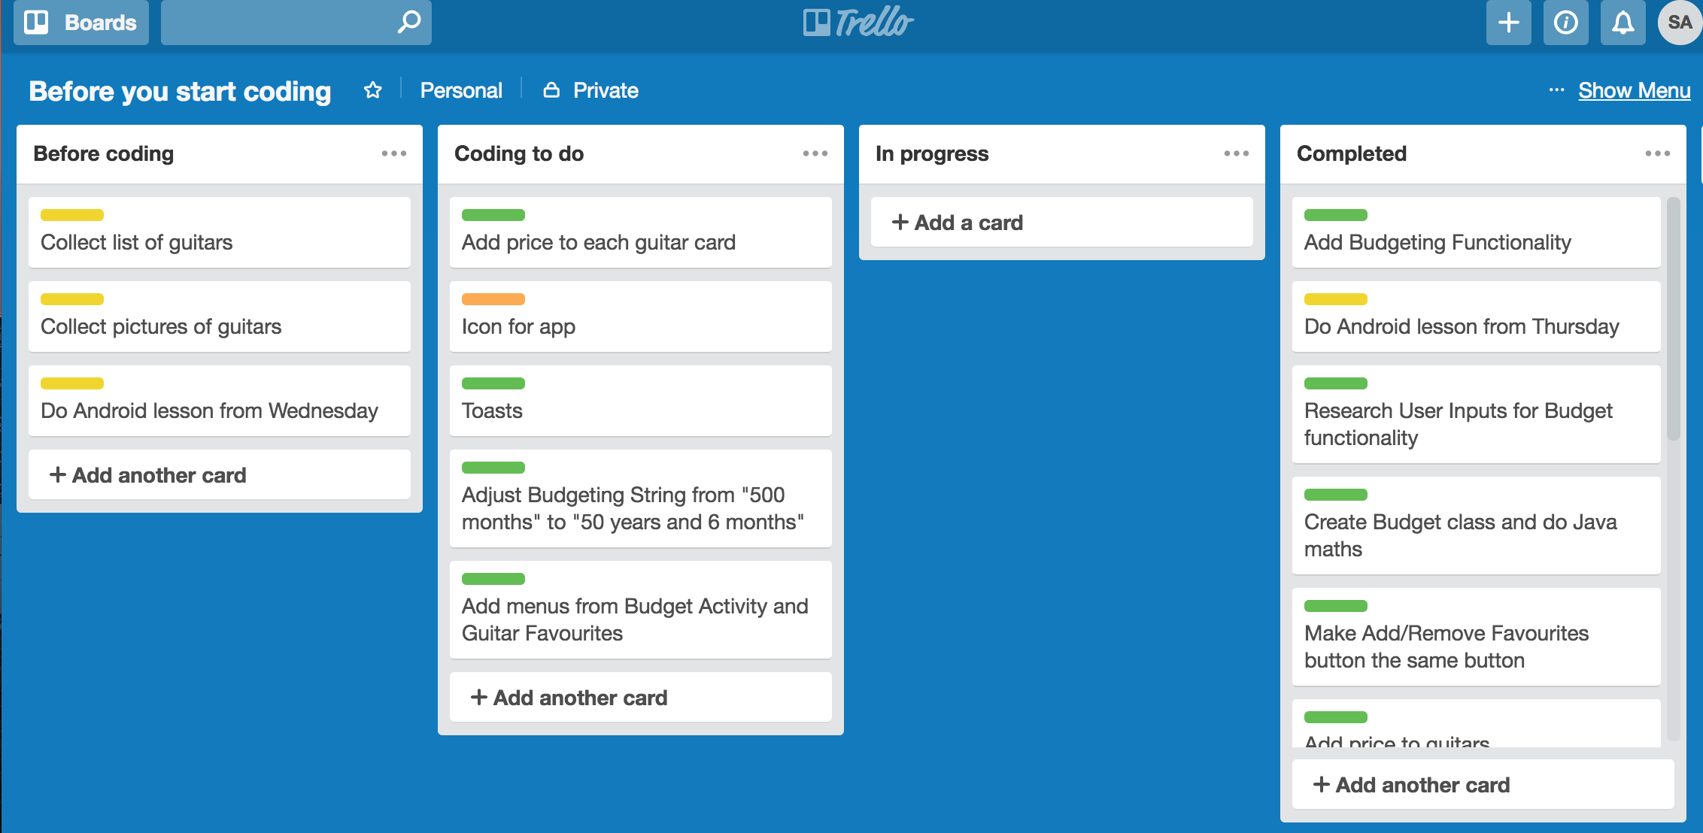

2. Proposed wireframes for 3 app activities plus additional fourth extension

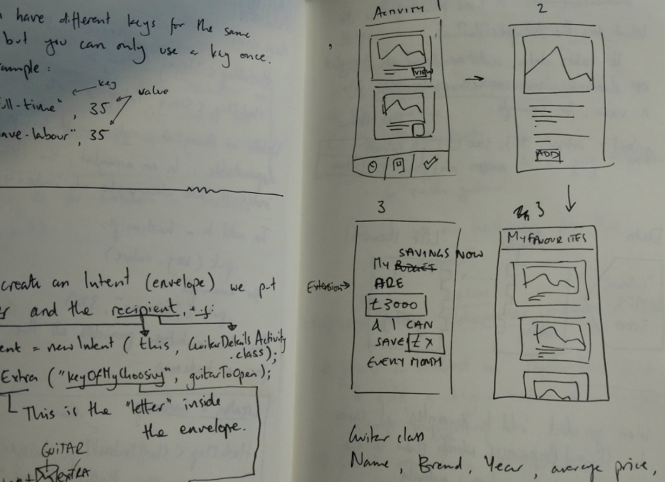

3. Completed app with ‘Favouriting’ function, now to plan ‘Budgeting’ function...

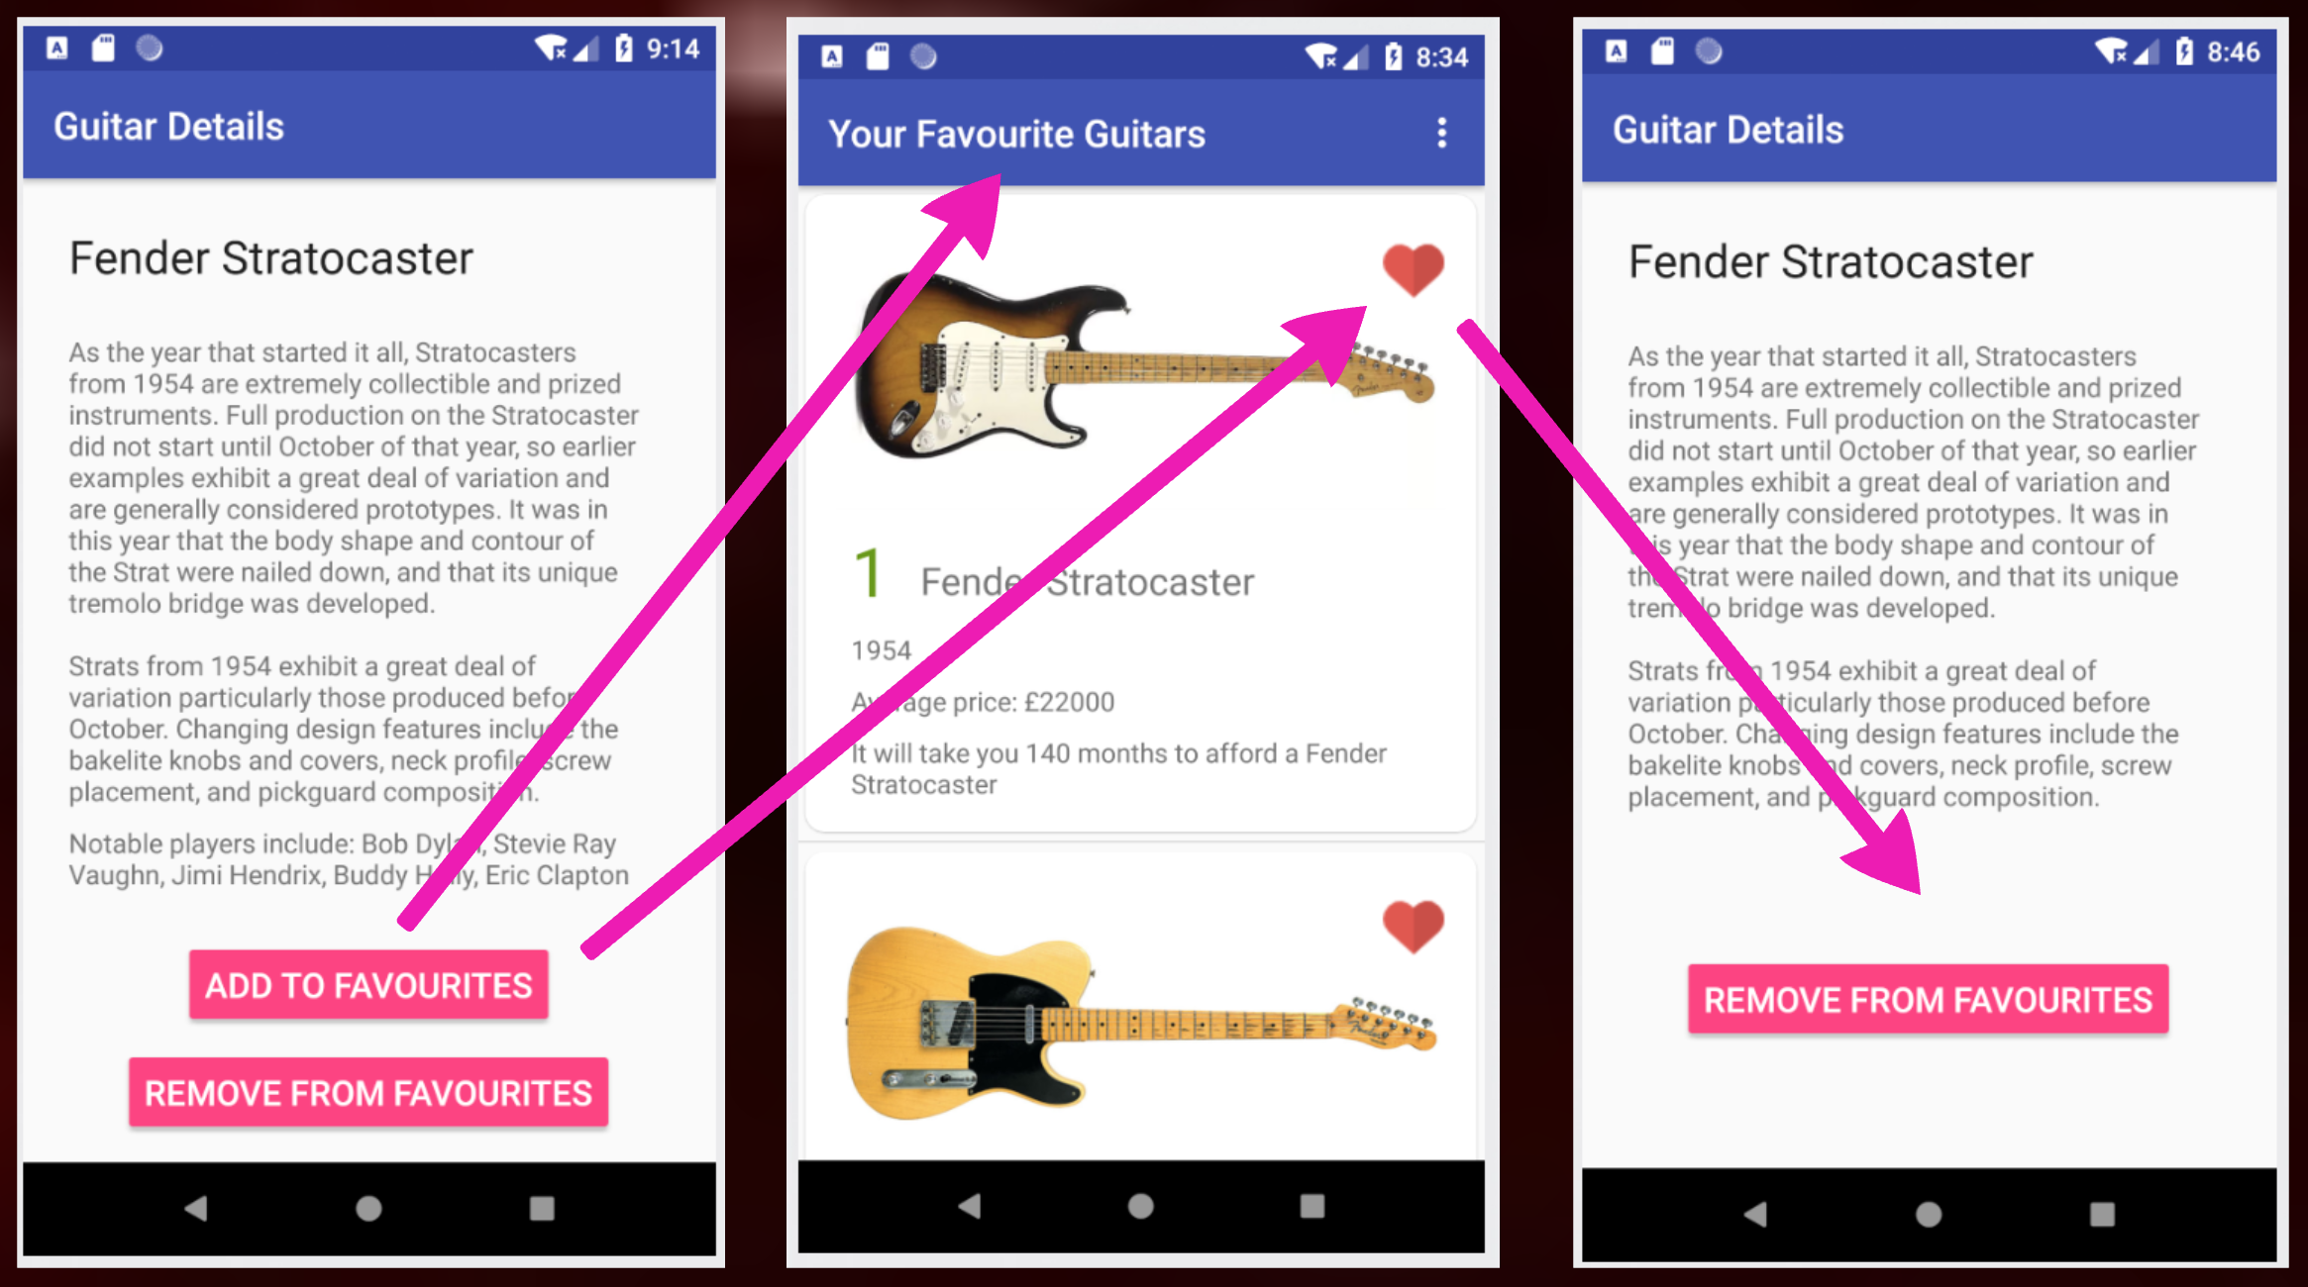

4. Extension completed with ‘Budgeting’ function

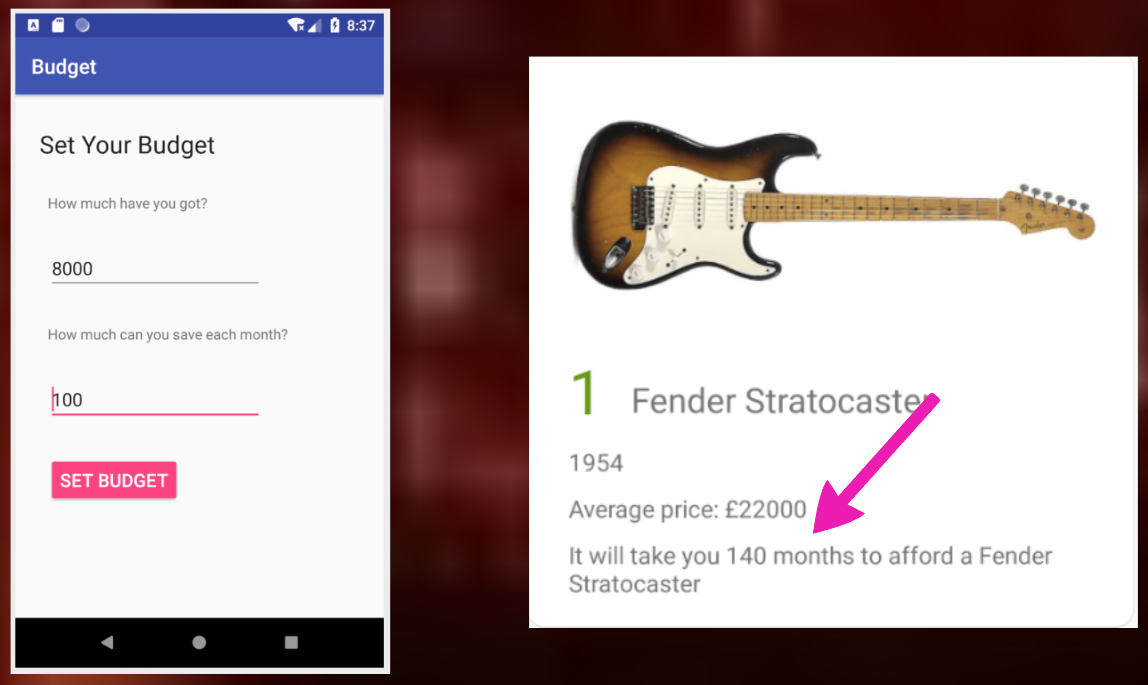

## P.13 User Input

User input being added

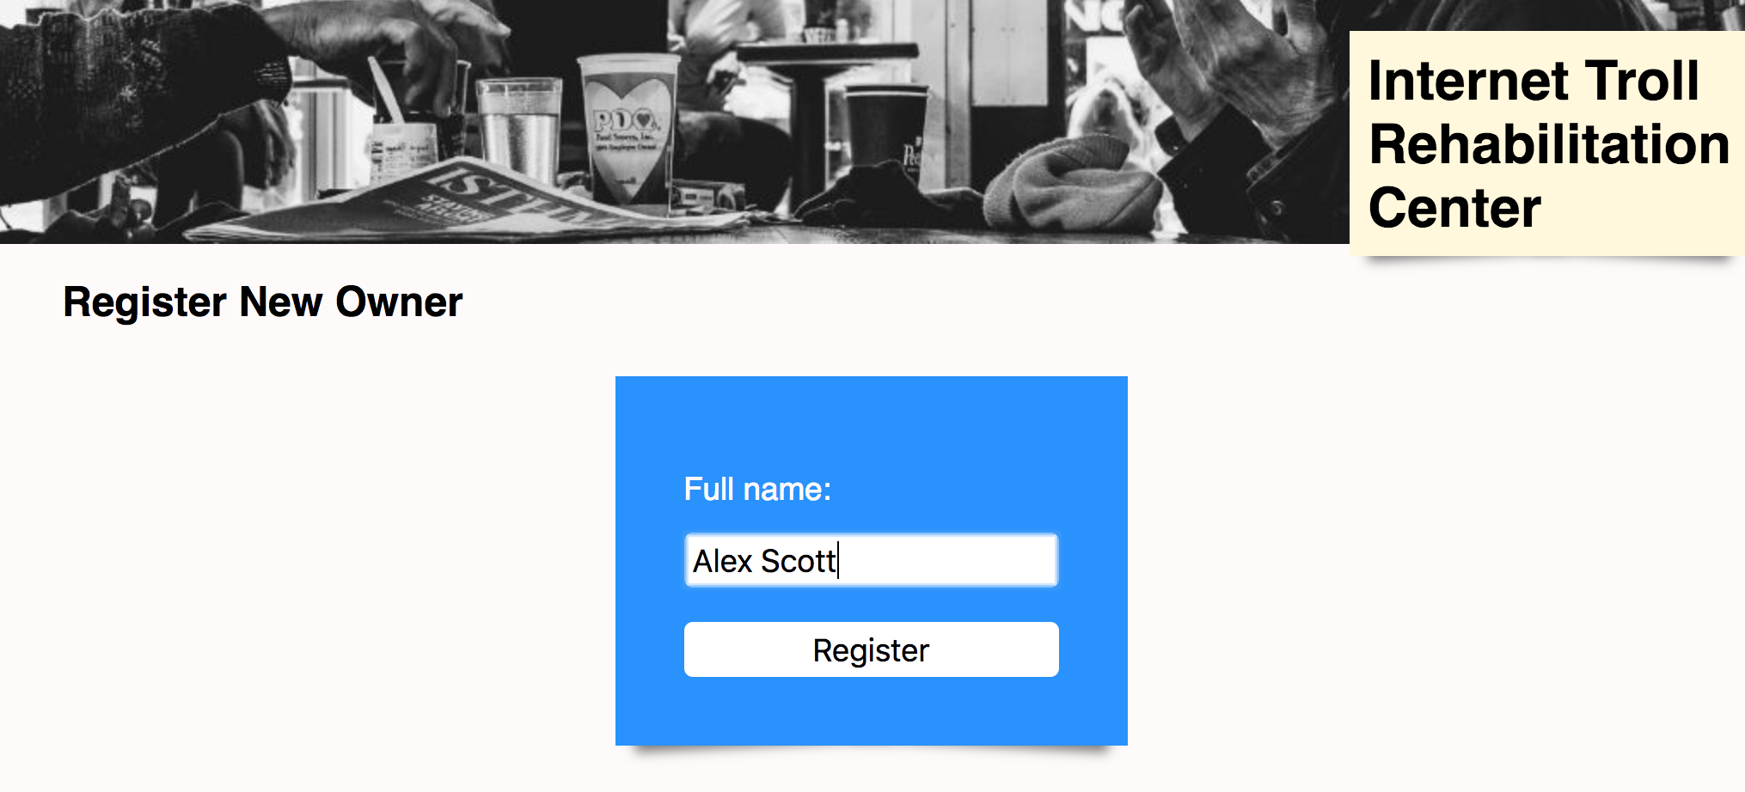

User input being saved as a new Troll Owner, Alex Scott bottom right

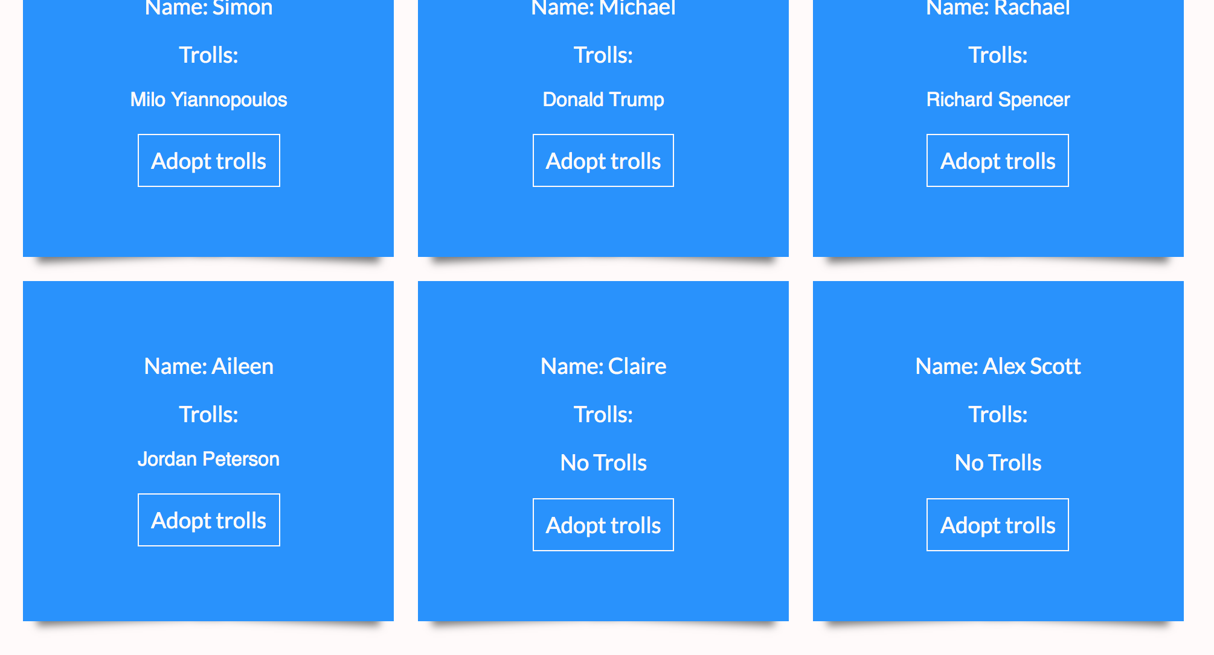

## P.14 Interaction with data persistence

Database before being edited and saved - See Donald Trump, Adoptable ‘Yes’

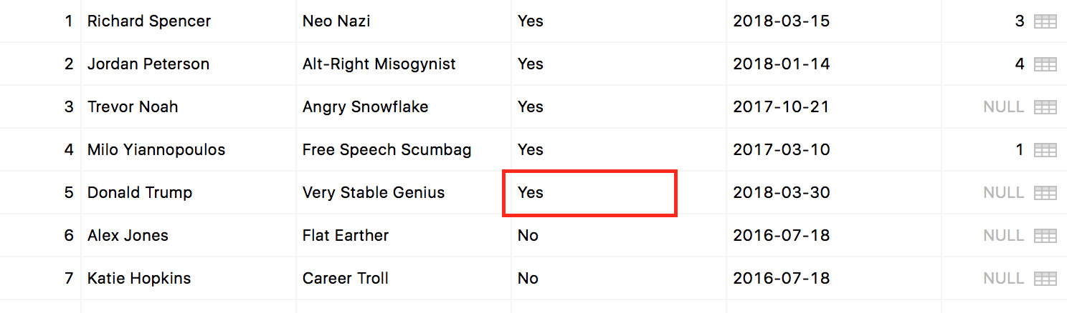

User view of data being inputted and edited for internet troll Donald Trump

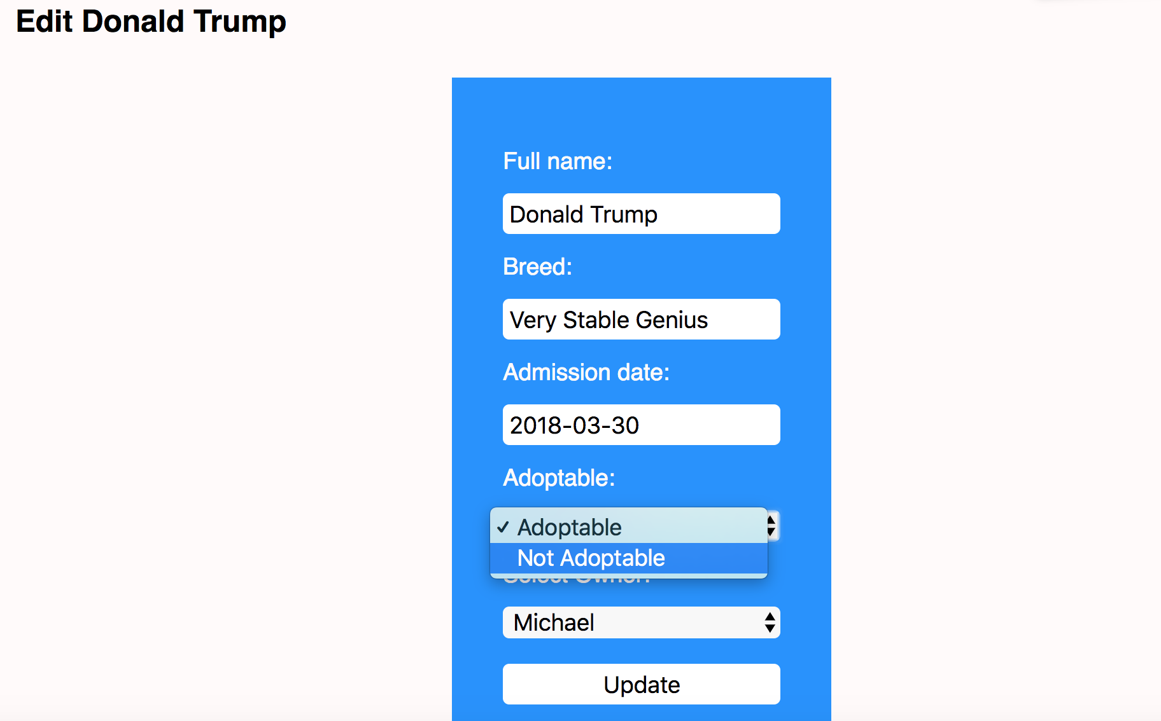

Confirmation of data having been saved on app (see Adoptable - No)

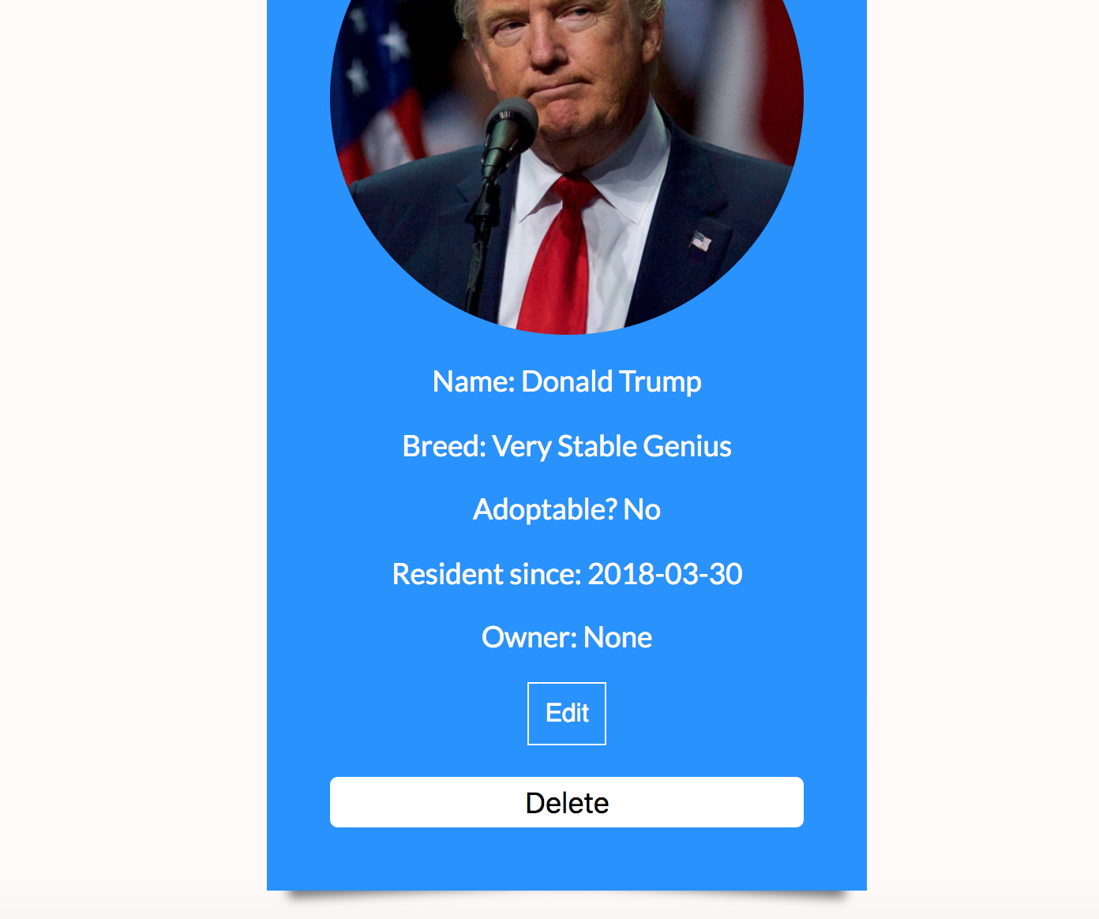

Confirmation of data having been saved in database (see Adoptable - No)

## 

## P.15 User output result

User requesting action to be performed (updating Alex Jones’ breed from ‘Flat Earther’ to ‘Conspiracy Theorist’)

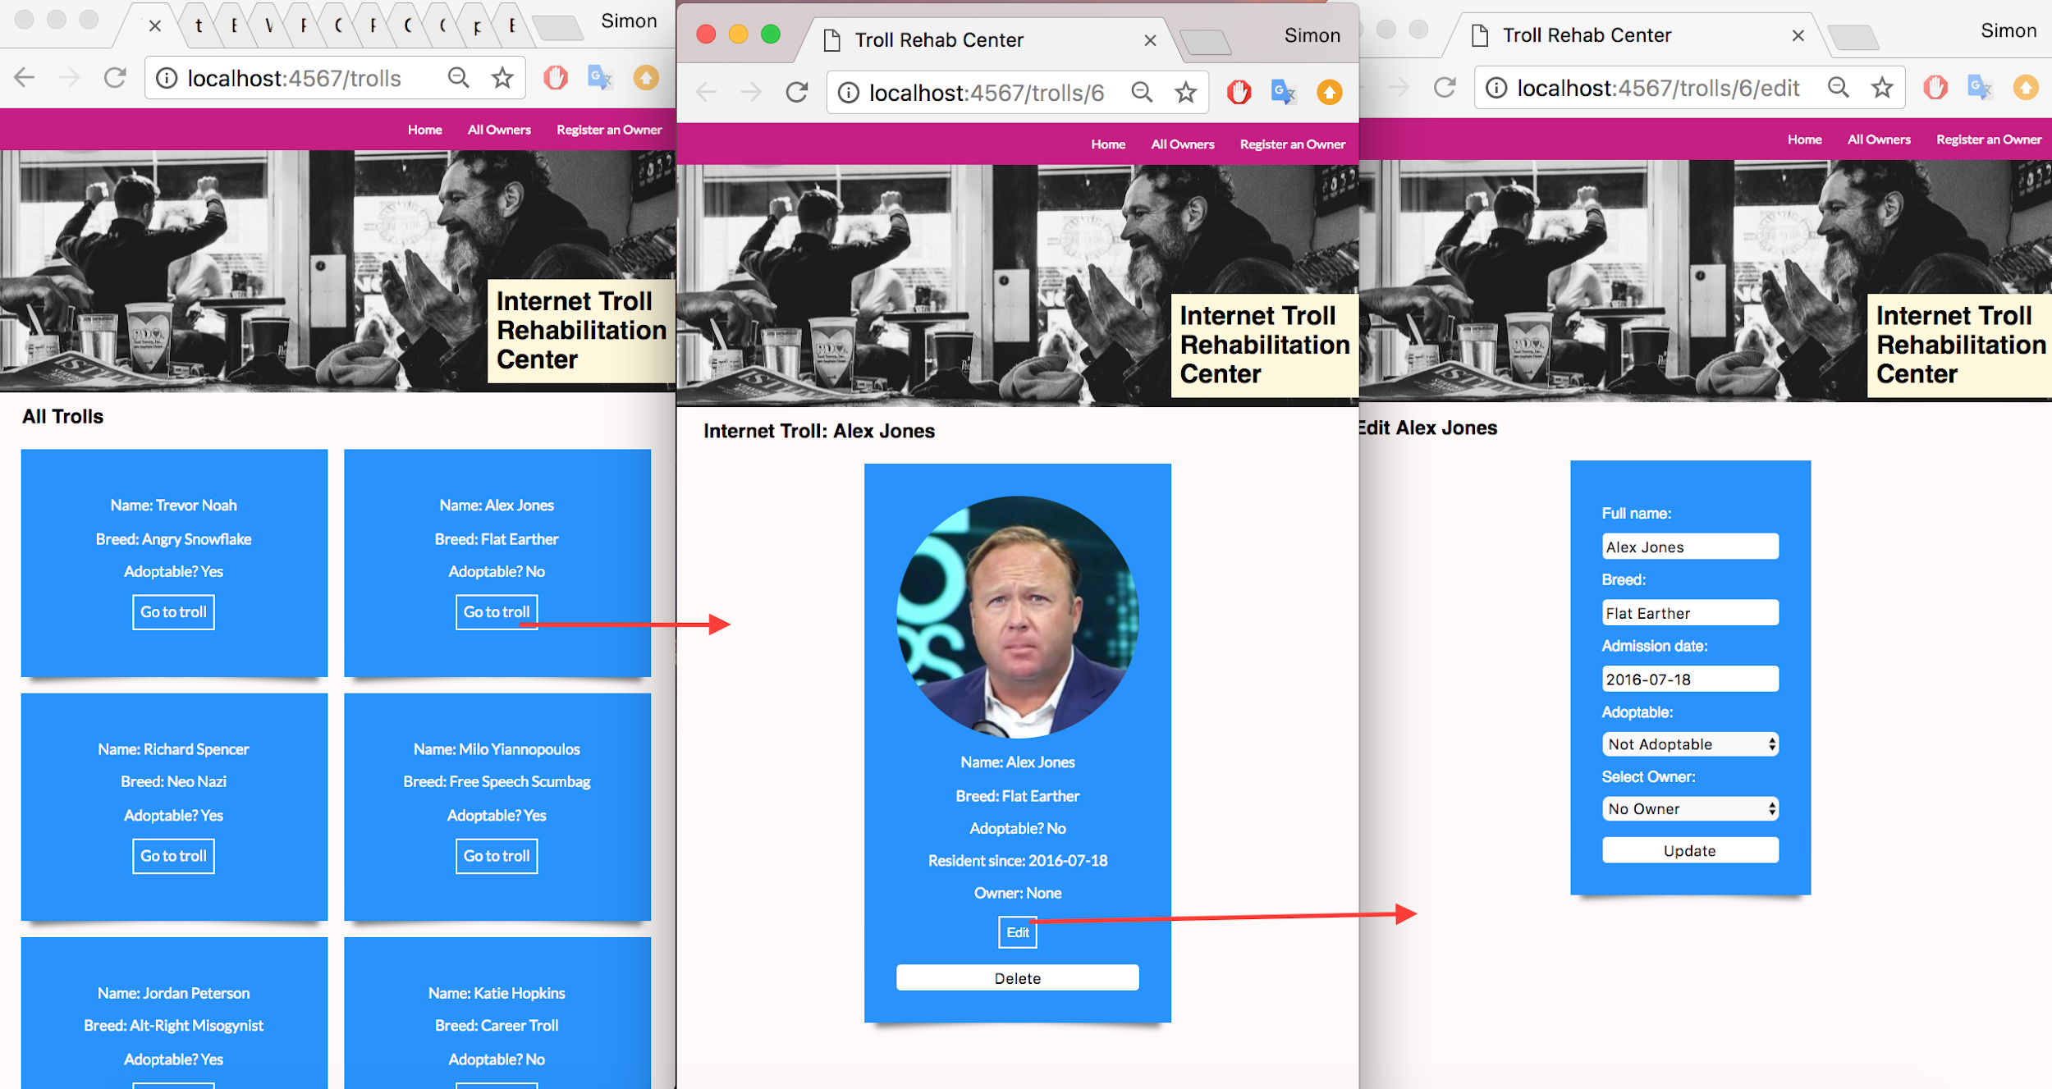

User input being processed and displayed in the programme

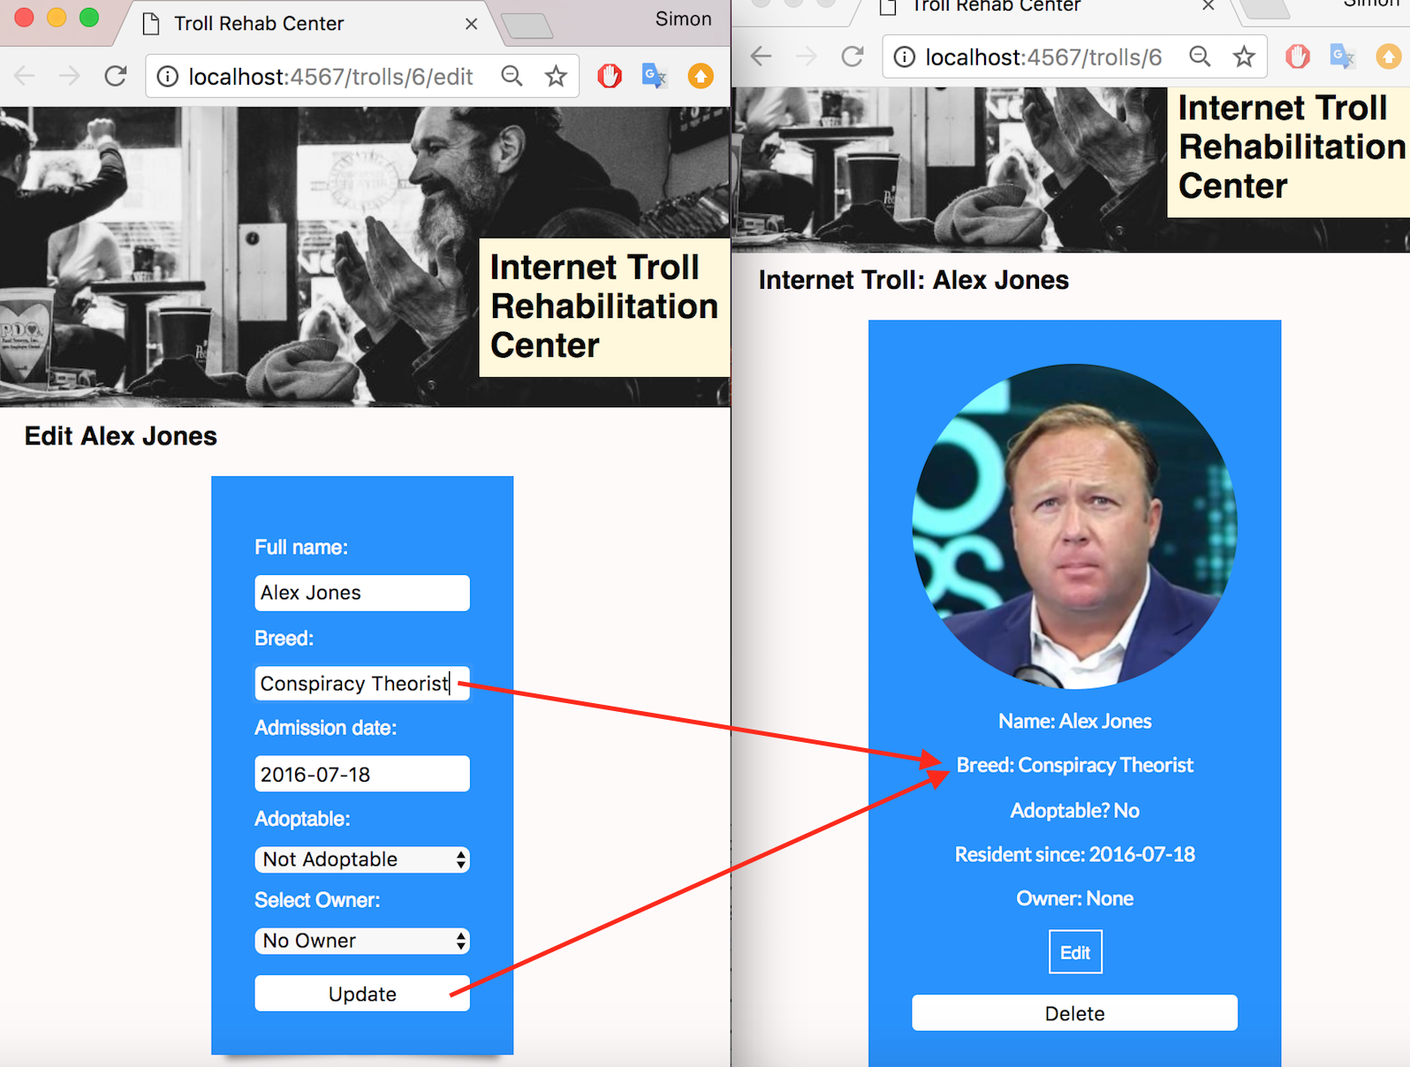

## P.16 Bug tracking report showing the errors diagnosed and corrected

## P.17 Testing your program

Show the test code, the test not passing, and then the text fixed.